***Ahsanullah University of Science & Technology***

Department of Computer Science & Engineering



Coding Cat

CSE 3224

Information System Design

&

Software Engineering Lab

Submitted By:

Ahmad Subaktagin Jabir 16.02.04.061

Arunima Ayshee 16.02.04.066

Rahat Bin Osman 16.02.04.083

Aniqua Tabassum 16.02.04.085

Date of Submission: **3 September, 2019**

**Project Motivation:**

In our society most of the newcomers or who want to do programming don’t know where to start from and also suffer from insecurities about their skill set being good enough to get them hired. So we wanted to provide a sophisticated solution that solves all of the above mentioned problems.

**List of Primary Actors:**

Primary Actors are those who stimulate the system and are the initiator of events. There are three types of Primary Actors in our project. They are-

* Talent
* Project Manager
* Problem Setter

**List of Secondary Actors:**

Secondary Actors are those who only receives stimuli from the system. There are three types of Secondary Actors in our project. They are-

* Talent
* Project Manager
* Banking Service (Credit Card, bKash)

**Use cases according to Primary Actors:**

A use case is a software and system engineering term that describes how a user uses a system to accomplish a particular goal. To be specific, it captures the functional requirements of a system. A use case acts as a software modeling technique that defines the features to be implemented and the resolution of any errors that may be encountered.

1. **Use Case Diagram of Talent:**

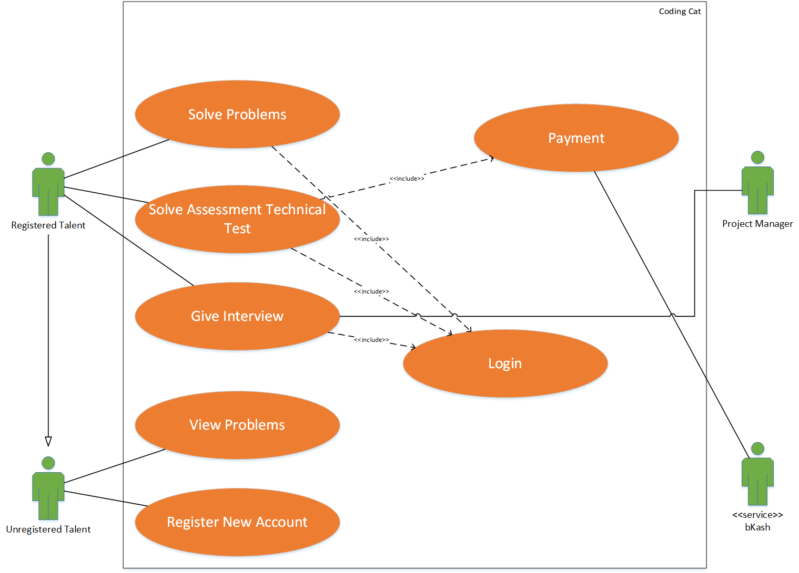

**Illustration:**

* **Building Skills:** Talents those who are registered can solve problems and climb leaderboards by earning rating points. Also they can buy premium assessment technical test and solve them to step their game ahead of others.
* **Getting Hired:** Talents can give interviews to willing project managers that are looking for talents with similar skill set.
* **Registering New Account:** Unregistered talents will be able to view the programming questions of the system. They will have to register into the system to solve the problems and to get other benefits.

The registered users will have to be logged into the system to solve problems

and to get points based on the solved problems.

1. **Use Case Diagram of Project Manager:**

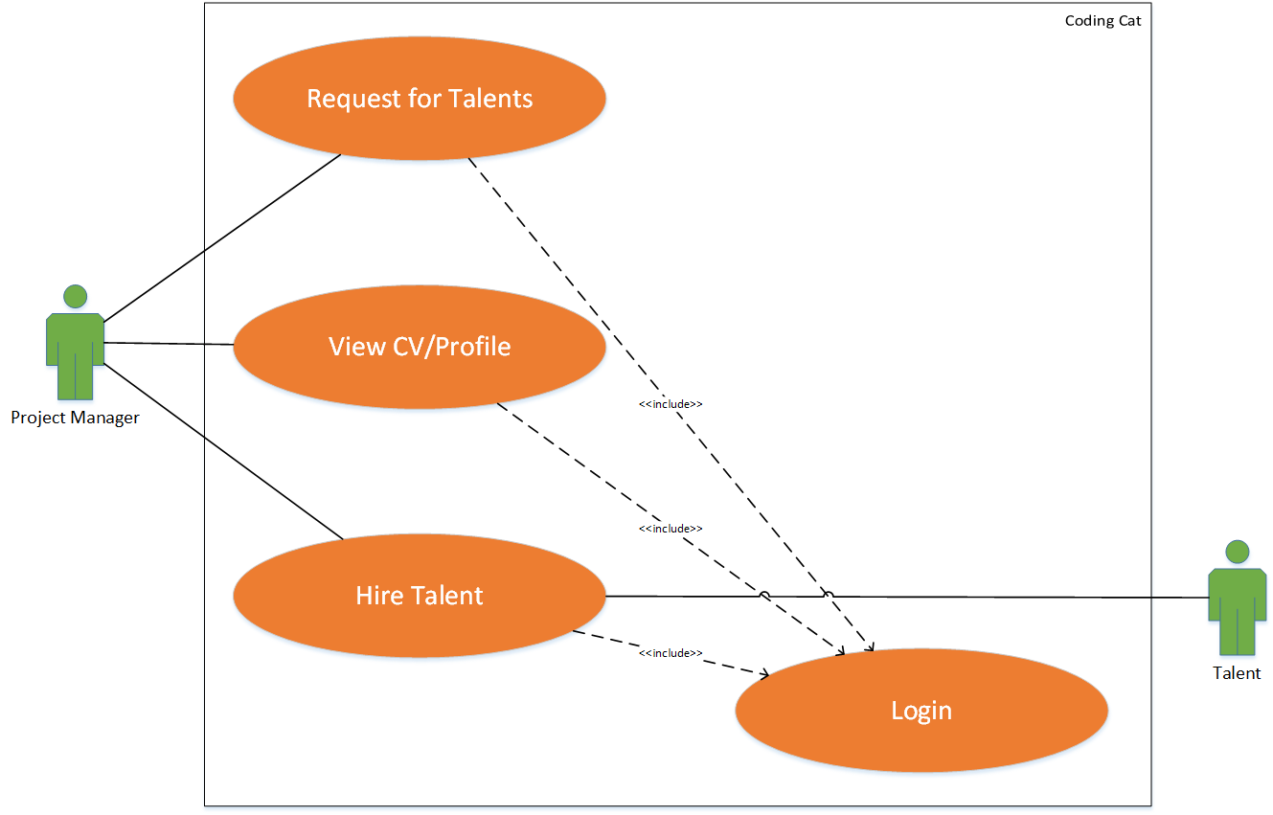

**Illustration:**

* **Search for Talents:** Registered company’s Project Managers can request for Talents to the system. Based on his/her criteria and required skill set, the system will suggest them talents to hire. From the suggested list, they can also view the CV and profile of the talents.
* **Hiring Talents:** Having a successful coding interview, if the project manager thinks the talent is suitable, he can hire him using the system.

Project Managers will have to be logged into the system before performing

any functionalities.

1. **Use Case Diagram of Problem Setter:**

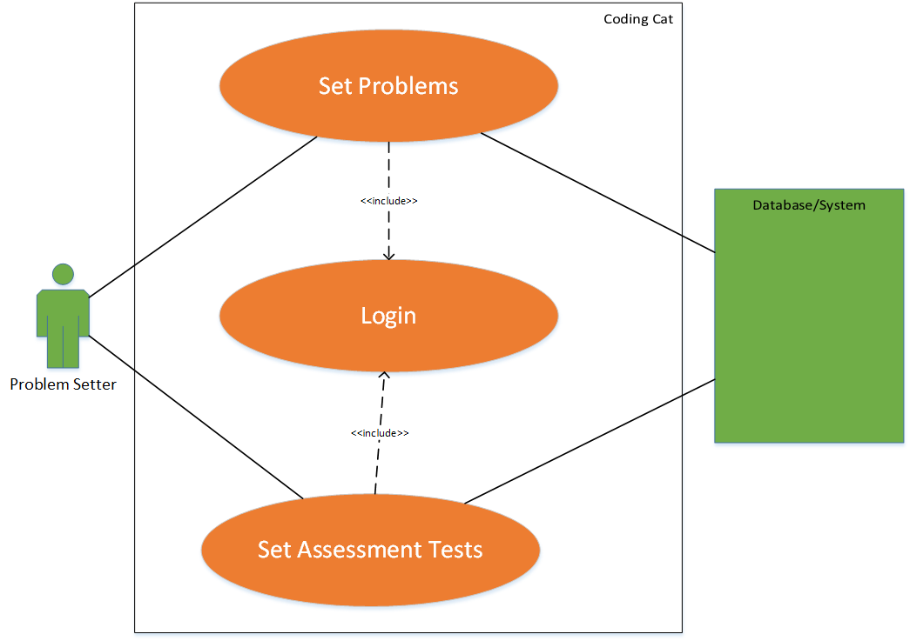

**Illustration:**

* The problem setters of our system will have limited access to the databases, so that they can update practice problems and industry standard assessment tests.

The problem setter needs to be logged into the system before making

changes in the database.

**Conclusion:**

Here, in this report, we have tried our best to capture all possible use cases from the primary and secondary actors’ point of views. We have also included and extended use cases that will make the system more interactive and user friendly. We hope that this will give a clear concept about all the functional requirements our system is supposed to have. Any mistakes are hoped to be seen in the eyes of forgiveness.